Why did Jesus liken His body to the temple at Jerusalem?
John 2:13-22
13 And the Jews' passover was at hand, and Jesus went up to Jerusalem,
14 And found in the temple those that sold oxen and sheep and doves, and the changers of money sitting:
15 And when he had made a scourge of small cords, he drove them all out of the temple, and the sheep, and the oxen; and poured out the changers' money, and overthrew the tables;
16 And said unto them that sold doves, Take these things hence; make not my Father's house an house of merchandise.
17 And his disciples remembered that it was written, The zeal of thine house hath eaten me up.
18 Then answered the Jews and said unto him, What sign shewest thou unto us, seeing that thou doest these things?
19 Jesus answered and said unto them, Destroy this temple, and in three days I will raise it up.
20 Then said the Jews, Forty and six years was this temple in building, and wilt thou rear it up in three days?
21 But he spake of the temple of his body.
22 When therefore he was risen from the dead, his disciples remembered that he had said this unto them; and they believed the scripture, and the word which Jesus had said.

It should be obvious from v22 that when Jesus spoke in v19 He was talking about His resurrection. But, what might not be obvious is why did He specifically choose to liken His body to the temple in Jerusalem?

The Jews asked Him for a sign and Jesus knew that they wouldn’t understand the deeper meaning of what He was saying. Notice how they didn’t even know that He was talking about His body and that He didn’t clarify that fact to them but He did to us (v21)? They asked for a sign and He gave them what they asked for. That sign is what the tabernacle/temple represented in the old testament.

Hebrews 10:1
For the law having a shadow of good things to come, and not the very image of the things, can never with those sacrifices which they offered year by year continually make the comers thereunto perfect.

From this verse in Hebrews we learn that the law (the first 5 books of the Bible also known as the Torah) has in it figures of things that would come in the future. For example, Moses is a figure/type of Christ but not Christ Himself. Study carefully what Moses did and how he acted and that becomes clear.

Because of what we learn here in Hebrews (and elsewhere) that also means that there are other things in the law that are figures of other things. In other words, we can read the old testament and learn more about things that God has done and will do in the future!

For example, the Holy Ghost in-dwelling believers. In Ezekiel, God is explicit about it:

Ezekiel 11:19-20
19 And I will give them one heart, and I will put a new spirit within you; and I will take the stony heart out of their flesh, and will give them an heart of flesh:
20 That they may walk in my statutes, and keep mine ordinances, and do them: and they shall be my people, and I will be their God.
Ezekiel 36:26-27
26 A new heart also will I give you, and a new spirit will I put within you: and I will take away the stony heart out of your flesh, and I will give you an heart of flesh.
27 And I will put my spirit within you, and cause you to walk in my statutes, and ye shall keep my judgments, and do them.
So, how does that connect with Jesus likening His body to the temple?

1 Corinthians 6:19
What? know ye not that your body is the temple of the Holy Ghost which is in you, which ye have of God, and ye are not your own?

What does that say? Your body is the temple of the Holy Ghost! In other words, a reborn human’s body is likened to a temple, wherein the Holy Ghost resides. Sound familiar?

John 6:56
He that eateth my flesh, and drinketh my blood, dwelleth in me, and I in him.
John 15:4-6
4 Abide in me, and I in you. As the branch cannot bear fruit of itself, except it abide in the vine; no more can ye, except ye abide in me.
5 I am the vine, ye are the branches: He that abideth in me, and I in him, the same bringeth forth much fruit: for without me ye can do nothing.
6 If a man abide not in me, he is cast forth as a branch, and is withered; and men gather them, and cast them into the fire, and they are burned.
Revelation 3:20
Behold, I stand at the door, and knock: if any man hear my voice, and open the door, I will come in to him, and will sup with him, and he with me.
1 John 4:15
Whosoever shall confess that Jesus is the Son of God, God dwelleth in him, and he in God.

Before we continue, let’s take a good look at the word tabernacle in the Bible and how that word is used. There are several ways we could do that and let’s look at two of them. The following is a summary of each Hebrew (6) and Greek (3) word rendered “tabernacle” throughout the entire Bible.

Exo 25:9 | H4908
Exo 26:9 | H168
Job 36:29 | H5521
Psa 76:2 | H5520
Lam 2:6 | H7900
Amo 5:26 | H5522
Act 7:43 | G4633
Act 7:46 | G4638
2Co 5:1 | G4636

The first and the last verse that any one of those from the previous summary appears is:

Genesis 4:20
And Adah bare Jabal: he was the father of such as dwell in tents^{H168}, and of such as have cattle.
Revelation 21:3
And I heard a great voice out of heaven saying, Behold, the tabernacle^{G4633} of God is with men, and he will dwell with them, and they shall be his people, and God himself shall be with them, and be their God.

And so we learn that a tabernacle is something that someone dwells in.

The following is a summary of every English word used in the Bible that came from one of those Hebrew/Greek words in the previous summary with their occurance count next to them:

booth | 2
booths | 9
cottage | 1
covering | 1
covert | 2
den | 1
dwelleth | 1
dwelling | 5
dwellingplaces | 3
dwellings | 6
habitation | 3
habitations | 3
home | 1
pavilion | 3
pavilions | 3
place | 2
places | 1
tabernacle | 326
Tabernacle | 1
tabernacles | 29
tent | 91
tents | 52
Total | 546

Notice a pattern? Booth...cottage...den...pavilion...home...tent...tabernacle...are all dwellingplaces!

The first time in the Bible that God uses the word tabernacle is when He begins to give instructions on how to build the tabernacle and it appears in the the law.

Exodus 25:8-9
8 And let them make me a sanctuary; that I may dwell among them.
9 According to all that I shew thee, after the pattern of the tabernacle, and the pattern of all the instruments thereof, even so shall ye make it.

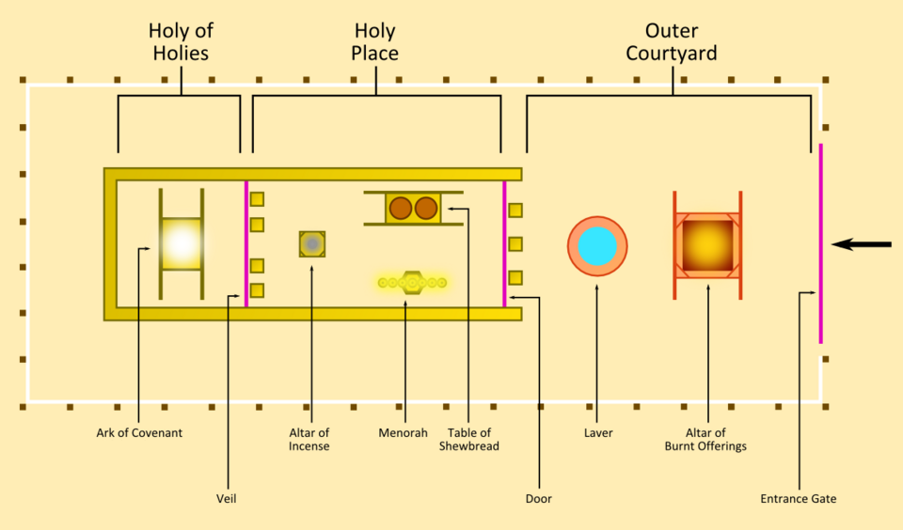

Where does God dwell in the tabernacle of witness (Acts 7:44)? In the “most holy place” (Exodus 26:34) which is labeled “holy of holies” in the diagram of the tabernacle to the right.

After the tabernacle was brought to Jerusalem by king David he wanted to build God a new house.

1 Chronicles 17:1-5,11,12
1 Now it came to pass, as David sat in his house, that David said to Nathan the prophet, Lo, I dwell in an house of cedars, but the ark of the covenant of the LORD remaineth under curtains.
2 Then Nathan said unto David, Do all that is in thine heart; for God is with thee.
3 And it came to pass the same night, that the word of God came to Nathan, saying,
4 Go and tell David my servant, Thus saith the LORD, Thou shalt not build me an house to dwell in:
5 For I have not dwelt in an house since the day that I brought up Israel unto this day; but have gone from tent to tent, and from one tabernacle to another.
11 And it shall come to pass, when thy days be expired that thou must go to be with thy fathers, that I will raise up thy seed after thee, which shall be of thy sons; and I will establish his kingdom.
12 He shall build me an house, and I will stablish his throne for ever.

And we can read about Solomon doing just that in 1 Kings:

1 Kings 6:1
And it came to pass in the four hundred and eightieth year after the children of Israel were come out of the land of Egypt, in the fourth year of Solomon's reign over Israel, in the month Zif, which is the second month, that he began to build the house of the LORD.

Notice that the tabernacle and Solomon’s temple are both called the temple (figuratively, they both represent the same thing):

1 Samuel 1:9
So Hannah rose up after they had eaten in Shiloh, and after they had drunk. Now Eli the priest sat upon a seat by a post of the temple of the LORD.
1 Samuel 3:3
And ere the lamp of God went out in the temple of the LORD, where the ark of God was, and Samuel was laid down to sleep;
2 Samuel 22:7
In my distress I called upon the LORD, and cried to my God: and he did hear my voice out of his temple, and my cry did enter into his ears.
1 Kings 6:3
And the porch before the temple of the house, twenty cubits [was] the length thereof, according to the breadth of the house; and ten cubits was the breadth thereof before the house.
Ezra 3:6
From the first day of the seventh month began they to offer burnt offerings unto the LORD. But the foundation of the temple of the LORD was not yet laid.
John 18:20
Jesus answered him, I spake openly to the world; I ever taught in the synagogue, and in the temple, whither the Jews always resort; and in secret have I said nothing.

So, let’s put these pieces together.
- Jesus likens his body to the temple.
- A reborn human’s body is likened to the temple because it is the temple of the Holy Ghost.
- A tabernacle (or the temple) is a dwelling place where someone lives.
- The law shows us patterns or figures of things to come.
  - Moses was a figure of Christ that would come.
- God dwelled in the tabernacle and in the temple in the old testament.
- Jesus said He would abide in and dwell in anyone who opened the door (of their heart).
- The Holy Ghost lives in reborn humans (Galatians 2:20).
  - The Spirit of God is the Spirit of Christ (Romans 8:9)
  - God the Father, Jesus, and the Holy Ghost are all one (1 John 5:7)

So, what then might the tabernacle/temple in the law be a figure of today? I think it could only be one thing:

Old testament shadow | New testament reality
Tabernacle, temple | The body of a reborn human

